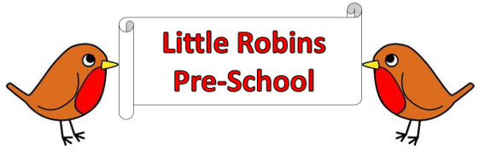

**General Welfare Requirement: Organisation**

Providers must plan and organise their systems to ensure that every child receives an enjoyable and challenging learning and developing experience that is tailored to meet their individual needs.

**Partnership**

**Working in partnership with other agencies**

# Policy statement

We work in partnership with local and national agencies to promote the well-being of all children**.**

# EYFS key themes and commitments

|  |  |  |  |
| --- | --- | --- | --- |
| **A Unique Child** | **Positive**  **Relationships** | **Enabling**  **Environments** | **Learning and**  **Development** |
| 1.3 Keeping safe  1.4 Health and wellbeing | 2.1 Respecting each other | 3.4 The wider context |  |

# Procedures

* We work in partnership or in tandem with, local and national agencies to promote the wellbeing of children.
* Procedures are in place for sharing of information about children and families with other agencies. This includes information regarding the EYFS Two Year Progress check. (Little Robins Pre-school will seek the consent of the parent before carrying out such checks)
* Information shared by other agencies with us is regarded as third party information. This is also kept in confidence and not shared without consent from that agency.
* When working in partnership with staff from other agencies, we make those individuals welcome in the setting and their professional roles are respected.
* We follow the protocols for working with agencies, for example on child protection.
* Staff from other agencies do not have unsupervised access to the child they are visiting in the setting and do not have access to any other child(ren) during their visit.
* Our staff do not casually share information or seek informal advice about any named child/family.
* When necessary we consult with local and national agencies who offer a wealth of advice and information that help us develop understanding of issues facing us and who can provide support and information for parents. For example, ethnic/cultural organisations, drug/alcohol agencies, welfare rights advisors or organisations promoting childcare and education, or adult education.