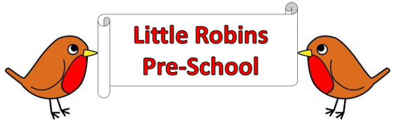

**General Welfare Requirement: Attendance**

Providers must plan and organise their systems to ensure that every child receives an enjoyable and challenging learning and developing experience that is tailored to meet their individual needs.

**Administration**

**Attendance**

**Statement of Intent**

This sets out the procedures to be followed in the event that a child is absent from Little Robins Pre-School.

**Procedures**

* Parents must inform us either verbally, by email or WhatsApp if they are planning on taking a holiday in term time so we can record this.
* We ask that if a child is sick or cannot attend pre-school for some reason that you let us know that day and if they are going to be absent for longer that you let us know via phone, text or WhatsApp.
* If a child is absent without prior notice, we will attempt to contact the parent/ carer to find out the reason for this from the first day of absence. By text, Phone and email.
* If we are concerned about the welfare of a child, we reserve the right to contact Social Services and/or the police.
* Fees remain payable during periods of absence, unless funded or alternative arrangements have been agreed.
* Contact number for absence and sickness is 07726676882 by 9:00am