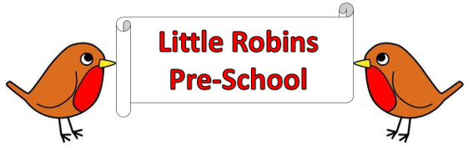

**General Welfare Requirement: British Values**

The provider must take necessary steps to safeguard and promote the welfare of children

**British Values**

**Promoting British Values at Little Robins Pre School**

The DFE have recently reinforced the need to create and enforce a clear and rigorous expectations on all schools and pre-schools to promote the fundamental British values of democracy, the rule of law, individual liberty and mutual respect and tolerance of those with different faiths and beliefs.

The government set out its definition of British Values in the 2011 prevent – strategy. At Little Robins these values are reinforced regularly and in the following ways.

**Democracy**

We listen to children’s and parent’s voices. Our behaviour policy is clear that children are expected to contribute and co-operate, taking into account the views of others.

**The Rule of Law**

We consistently reinforce our high expectations of children. Children are taught to value and reasons behind our expectations (rules), that they are there to protect us, that everyone has a responsibility and that there are consequences when rules are broken.

**Individual Liberty**

Within pre-school, children are actively encouraged to make choices, knowing that they are in a safe and supportive environment. As a pre-school we educate and provide boundaries for children to make choices safely, through our provision of a safe environment and empowering teaching children are encouraged to know, understand and exercise their rights and personal freedoms.

**Mutual Respect**

Part of our behaviour policy has revolved around core values such as ‘Respect ‘and children are modelled this by caring, sharing, and listening to others. Staff help children to understand how to respect by talking about how actions/words can affect others.

**Tolerance of those of Different Faiths and Beliefs**

We aim to enhance children’s understanding of different faiths and beliefs by participating in a range of celebrations throughout the year. Children may have the opportunity to dress up in clothes and try different foods from other cultures, etc., and we encourage parent/carers to participate and support our multi – cultural events.