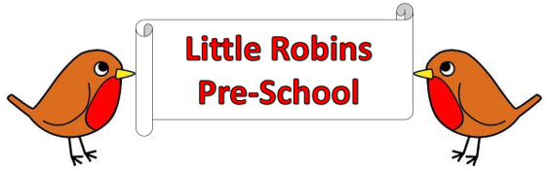

**General Welfare Sun Protection Policy**

Providers must plan and organise their systems to ensure that every child receives an enjoyable and challenging learning and developing experience that is tailored to meet their individual needs.

**Sun Protection Policy**

**Statement of Intent**

At Little Robins Pre-School we take seriously the health + safety of children in our care. We believe that children should be allowed to play outside as much as possible during the warm weather.

**Aim**

To enable the children to enjoy outdoor play safely in the sun, by protecting them and educating them to safe behaviour when in the sun.

**Methods**

* We have canopies to provide long term shade.
* Outdoor activities will be set up in shady areas such as under the canopy to encourage children to play out in the sun.
* Offering free flow so children can choose to play inside.
* Water available for children to drink at all times.

Sun cream

* Pre-school provides sunscreen for children that attend all pre-school all day
* Letters are sent home asking parent’s permission for staff to apply sunscreen
* Children with allergies /eczema can provide their own sunscreen, the bottles will be labelled and kept with other sunscreen. Parents must still sign permission letter.
* Parents are asked to apply sunscreen before they attend pre-school and we will reapply sunscreen later in the day if needed.
* Sunscreen will be applied as and when necessary.